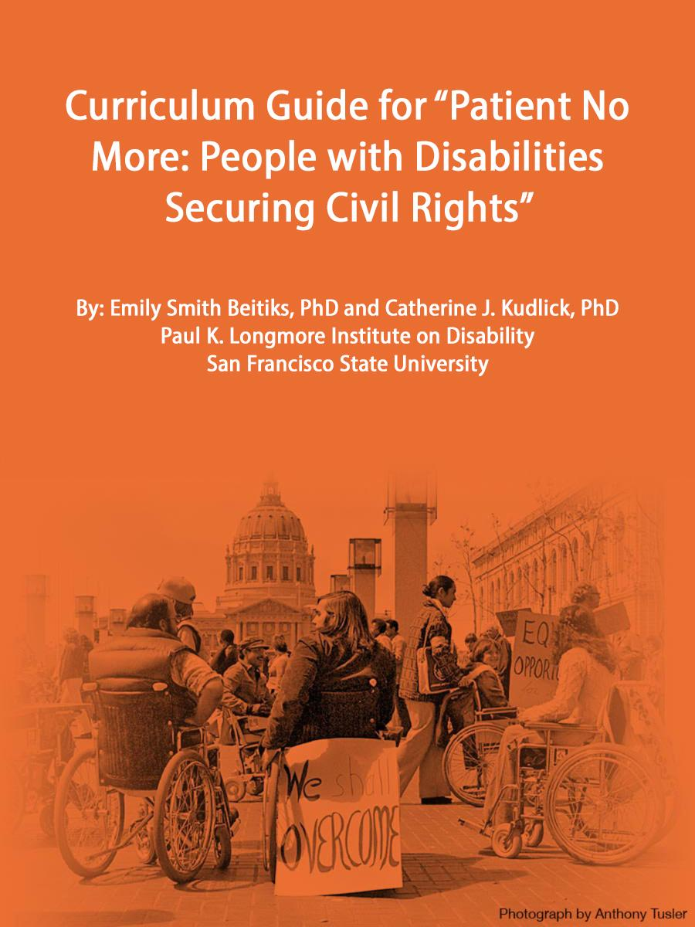

Curriculum Guide for “Patient No More: People with Disabilities Securing Civil Rights”
By: Emily Smith Beitiks, PhD and Catherine J. Kudlick, PhD
Paul K. Longmore Institute on Disability
San Francisco State University

Introduction to Using this Guide:

In 2011, California passed the FAIR Education Act, which mandates including disability history in K-12 curriculum. While we are excited about this recognition of the importance of this exciting new area, we know that teachers are already overworked, and bringing in another topic may be daunting. One of our primary goals in developing the “Patient No More” exhibit and this curriculum was to provide an opportunity for teaching disability without having to do some generic "people with disabilities are just like you and me" lesson… or just a quick unit on Helen Keller before moving on. Teaching the story of the 504 occupation, the focus of our exhibit, will undoubtedly leave students with a new perspective toward living with a disability. In the words of disability protesters, "Piss on Pity!" Rather, “Patient No More” offers a story about the creativity and strength that comes out of the disability community, an incredible example of how change can happen from the bottom up. It's also a story about how disability rights have changed the lives of all Americans in ways they might not realize.

We've prepared these materials to help you bring disability history into your classroom; included are activities meant to be taught using the virtual "Patient No More" exhibit. Generally, we designed this curriculum for grades 7-12, so adjustments may need to be made for your unique situation. Tips and tweaks welcome!

The virtual exhibit can be accessed at https://longmoreinstitute.sfsu.edu/patient-no-more/virtual-tour.

Additional reading materials and resources that pair well with the “Patient No More” exhibit can be found in Appendix A (Pages 35-36) and also accessed at: http://longmoreinstitute.sfsu.edu/patient-no-more/learn-more-about-504-protests.

We welcome your feedback to make this tool more useful. Don't hesitate to reach out to us at pklinst@sfsu.edu.
To provide context and link the "Patient No More" story to more familiar topics and concepts, this Curriculum Guide first details the historical significance of the disability rights movement and the Section 504 protest, then follows with activities designed to be used in conjunction with the virtual "online tour" of the Patient No More exhibit.

Activity Name | Page Number
Defining disability, historical background, 504 occupation, and guiding questions. | 4 - 10
LESSON 1: Universal Design and the Ed Roberts Campus | 11 - 14
LESSON 2: Government in Action: What’s in a law? | 15
LESSON 3: “This is 504!” | 16 - 17
LESSON 4: Thinking like an Organizer | 18
LESSON 5: Exhibit Scavenger Hunt | 19
LESSON 6: “Patient No More” Questions | 21 - 21
LESSON 7: What makes you “Patient No More”? | 22
LESSON 8: Audio Description | 23 - 28
APPENDIX A: Additional Resources | 29 - 30

Defining Disability:
“Patient No More” promotes what is known as a "social" or "minority model of disability." In other words, disability is not a matter of an individual’s biology or medical impairment, but rather something formed in relation to society’s discriminatory environments and attitudes. We named our exhibit “Patient No More” as a double entendre. The 504 participants exhausted their patience waiting around for the enforcement of Section 504. But also, by advocating for people with disabilities as deserving of civil rights, they were fighting back against the "medical model of disability," which treats disabled people as patients who can best be fixed through medical interventions or doing whatever it takes to be as much like nondisabled people as possible. In recent years rigid distinctions between the two approaches have come under criticism as scholars acknowledge medical benefits. But for teaching purposes, the contrast between the medical and social are useful and instructive, as can be seen in the different approaches discussed in more detail below.

To learn more about the social, medical, and additional models of disability, visit the glossary list at: http://www.disabled-world.com/definitions/disability-models.php

Historical Background:
Though nearly one in five Americans identify as someone living with a serious disability, the phenomenon has long been understood as something abnormal and far removed from mainstream society. Most often we approach disability as a biological misfortune that befalls unlucky individuals, something that can only be fixed through medical interventions and rehabilitation. This focus ignores how social values and beliefs shape popular perceptions of disability and disabled people. One meaning of the exhibit title “Patient No More” reflects a need for thinking of people with disabilities as a minority group rather than as people waiting passively for cures that may or may not ever arrive.

Disability history seeks to promote thinking of people with disabilities as actors in their own right. It is still new even at the college level, but thanks to exciting discoveries over the past two decades, the field is full of surprises with links to more familiar topics such as war, immigration, social justice movements, and civil rights (see: Catherine Kudlick, “Disability History: Why We Need Another 'Other'" American Historical Review (2003) for a general introduction to the field). “Patient No More" offers a new perspective on recent US history with tie-ins to civics and government, design, and much more.

“Patient No More” introduces this new understanding of disabled people by focusing on a largely overlooked yet highly significant moment in US history when they demanded their civil rights and won.

The seeds of an audacious disability rights movement sprouted in northern California during the already turbulent 1960s when Ed Roberts (1939-1995), a polio survivor who used a wheelchair and an iron lung, fought to attend mainstream schools in a world without required curb cuts and wide entrances. At a time when few believed people with disabilities could or should be educated and employed, Roberts defied prejudice and architectural barriers to attend UC Berkeley, California’s premier public university. In 1962 - the same year that James Meredith first attended the University of Mississippi - Roberts became the first highly-publicized student with significant disabilities to enter the university. Officials housed him in the campus infirmary because no residences could accommodate his massive 800-pound iron lung. His example inspired others with disabilities to apply, and soon Cowell Hospital became the de facto disabled student dorm.

These “Rolling Quads” helped launch a new way of thinking about disability by framing access and empowerment as civil rights issues. Eager to leave hospital wards to live on their own, they founded the Berkeley Center for Independent Living (CIL), which over the years grew to include peer counseling and support groups, workshops for repairing wheelchairs and testing adaptive equipment, training in self-advocacy, a clearinghouse for locating attendant-care services, legal assistance, and a place just to be with others who ‘got it’ about living with a disability. The idea of such centers run both by and for people with disabilities spread rapidly, ultimately inspiring more than 400 autonomous, community-based independent living centers across the country that persist down to the present. Public examples such as these centers introduced images of people with disabilities as problem-solving Americans who took risks and participated in politics and public life.

Section 504 Occupation and “Patient No More”:
The exhibit focuses on the story of what would become known as "the Section 504 Occupation" in a thematic, nonlinear way. The 504 occupation was a series of protests related to the newly-arrived Carter Administration’s failure to enforce previously-passed disability legislation; these protests galvanized a group of people, many of whom hadn’t thought of themselves as activists before. Buried in the so-called Rehabilitation Act, redesigned in 1973 to accommodate returning Vietnam veterans, was a provision based on the 1964 Civil Rights Act stipulating that individuals with disabilities “should not be denied the benefit of, or be subjected to discrimination under any program or activity receiving federal financial assistance.”

Cast in broad terms and bureaucratic language, Section 504 - which would serve as a model for the ADA thirteen years later - basically said that everything touched by the U.S. government needed to be fully accessible to people with disabilities: schools, universities, public offices, transit systems, hospitals, etc. Enforcement of these provisions languished for over four years due to pressure from organizations fearing it would prove too costly. After four years of government stalling, people with disabilities took action. Protests organized by the American Coalition of Citizens with Disabilities (ACCD) began on April 5, 1977. Women and men of diverse racial and socio-economic backgrounds riding wheelchairs, wielding white canes and crutches, using various forms of communication arrived with special care attendants, friends, and family at the ten regional Health, Education, and Welfare (HEW) government offices across the United States in a series of unprecedented shows of civil disobedience. They soon fizzled out everywhere except San Francisco.

This curriculum traces this exciting history by following three basic interweaving questions that could help structure assignments and course objectives:

QUESTION 1: What forces enable activism to flourish?

The Bay Area – along with Washington, DC, New York, and numerous other cities across the country – became the flashpoint of a national disability rights movement that burst onto the scene in the mid-1970’s as part of larger transformations sweeping the country. The Bay Area sit-in proved to be the most dramatic and enduring. The highly organized action received in-kind help from an unlikely coalition of groups ranging from the McDonald’s and Safeway food chains to the Black Panthers and the gay men’s “Butterfly Brigade” as well as several labor unions and the Glide Memorial Church. The occupiers also had backing from Mayor George Moscone and U.S. Representative Philip Burton, and eventually Governor Jerry Brown. In addition, tacit support from local police who allowed food into the building helps explain why the San Francisco occupation lasted longer than elsewhere. Outside, disability-rights crusader Ed Roberts – now head of the California Department of Rehabilitation that had once denied him services because of his apparently poor employment prospects – asked the crowd of television and newspaper reporters: “Are we going to perpetuate segregation in our society for one of the largest minority groups in the nation?” Once the steadfast dedication and growing public support for the occupiers became clear, Health, Education and Welfare Secretary Joseph Califano signed the 504 legislation, laying the groundwork for passing the ADA thirteen years later.

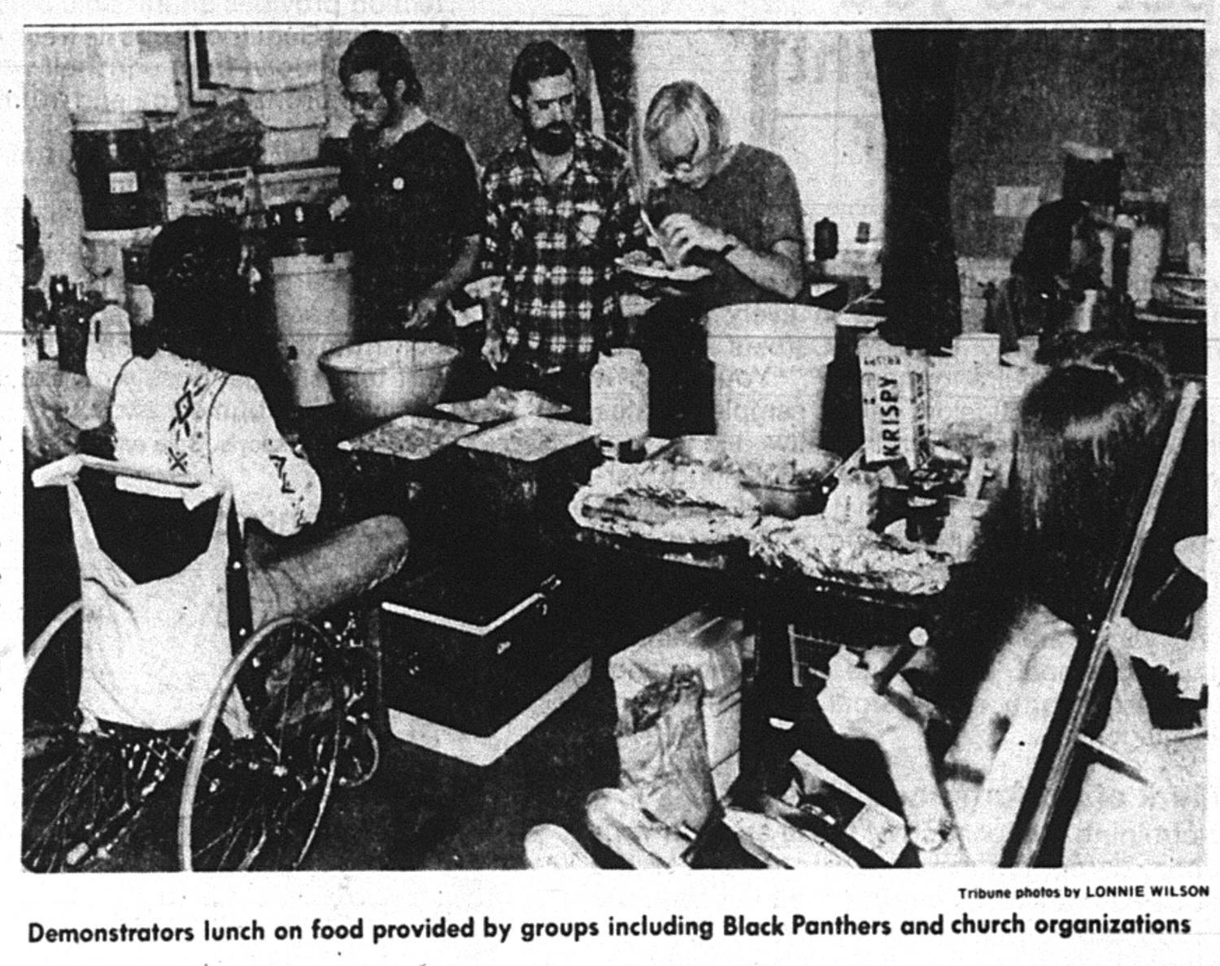

This newspaper clipping shows supplies donated by groups like Glide Memorial Church and Delancey Street Foundation, a non-profit working with ex-prisoners, alcoholics, and drug addicts. (Photography by Lonnie Wilson, courtesy The Oakland Tribune).

This victory energized disabled Americans both individually and collectively, offering for one of the first times in history the example of a cross-disability coalition and the hitherto untapped power within. No one expected it to last so long. Some had never slept away from home before. One of the lead organizers reported arriving with “a toothbrush and a pair of panties” while another came with a sleeping bag and a banana. At first the workers in the Federal Building didn’t take the protesters seriously – they let them into the building because they sarcastically said, “What are they going to do, stay here?” But hours slipped into days and then into weeks as occupiers had to work out ways to carry out the basic functions of daily living, many of them complex and sometimes even life-threatening because of disability. The experience of spending more than three weeks in close proximity among people with a wide array of disabilities during what became simply known as “504” fostered an esprit de corps that led in turn to the building of coalitions that would have been unimaginable a few years earlier.

Related exhibit panels:
- Independent Living Grows
- Building Networks of Support
- Patient No More: Demanding Change Video
- Protesting Across the United States
- Food for Change
- Educating a Nation
- Political Theater
- San Francisco Protestors in DC

QUESTION II: What Stories Remain to Be Told?

The San Francisco 504 Occupation that proved to be a turning point for many in the US disability rights movement brushed aside certain tensions that would resurface years later in sorting out the legacy. As research by Leroy More and Susan Schweik and the experiences of Corbett O’Toole reveal (see video “No Movement is Perfect” and articles in the references section), influential participants had effectively used strategies from civil rights and farm worker struggles, a fact that grounded disability rights in these ideas individually, philosophically and politically. Yet while the occupation brought together an extraordinary range of people with different disabilities in a public, unapologetically political way, and while the group had a number of key people of color and even enjoyed support from the Black Panthers and Mission Rebels, the leaders and spokespeople were clearly white. Over the decades this led to some stories fading from the record and to deep resentment. Add to this that not all groups focusing on race and civil rights totally got it about disability, and historians are left with incomplete accounts and missing voices.

Rather than continue the tradition of burying these stories, "Patient No More" approaches this complexity as an opportunity to delve more deeply into the messiness of building coalitions and the problems of intersecting, and often conflicting, identities. Essential figures such as Bradley Lomax, who served as the occupation’s bridge to the Black Panther Party, went to his grave having never been given adequate attention from a disability movement now dominated by white leadership, some of them oblivious to and even uncomfortable with questions of race. Meanwhile the black liberation movement never fully understood his identity as a disabled person. Because of poverty and lack of resources, disability figures more prominently in communities of color that could greatly benefit from the stories and lessons of 504.

Related exhibit panels:
- Building Networks of Support
- Food for Change
- Untold Stories of 504

QUESTION III: Where do we find creativity and ingenuity
because of disability, not in spite of it?

Over one hundred people with disabilities occupied an office building that was, of course, inaccessible. They immediately had to figure out how to go to the bathroom, how to sleep, how to keep medications cold without a refrigerator. And yet, they thrived to such an extent that when it was time to leave the building 26 days later, many protesters were reluctant to leave, so happy with the community they had formed.

When police first cut the phone lines and pay phones clogged up with coins, Deaf people easily communicated to the outside world by using American Sign Language. Blind people fed and toiletted quadriplegics; in exchange quadriplegics read aloud press releases and news articles to blind people. Once people with disabilities had shown this prospect to the outside world, and indeed to themselves, there would be no turning back. "Patient No More" showcases these examples of people with disabilities bringing new skills to the table not in spite of, but precisely because of their disabilities.

After reviewing the video and article about the Ed Roberts Campus, students will have an opportunity to reflect on this question through the architecture of the building, a place similarly inspired by the idea that solutions for dealing with disabilities often have unintended benefits for nondisabled visitors. Following the principles of universal design, where you build to include the broadest population and array of users possible, the Ed Roberts Campus has been called the most accessible building in the world. As a result, many nondisabled people enjoy its unique features as well. For example, large elevator buttons just above the floor allow wheelchair users to call the elevator with a bump of their wheelchair. Nondisabled people carrying a heavy load in their arms can also call the elevator by tapping the buttons with their feet.

Related exhibit panels:
- At Home in the Federal Building
- Building Networks of Support

"Patient No More" Guiding Questions for Reflection and Discussion:

The following guiding questions were crucial to the development of "Patient No More" and may give you some ideas for central stories and themes to highlight:
- What makes social change possible?

- What motivated people, many without previous activist experience, to occupy the building?

- How did the 504 protesters change perceptions of disability?

- How does the presence of disability alter the experience and impact of a "sit-in"?

- Who were the unsung heroes of 504 and why were their stories previously neglected in retellings of the demonstration?

- What hierarchies existed within the movement and how were these tensions dealt with (in 1977 and afterward)?

- How was disability activism similar/different from other social movement struggles such as "black power," "LGBT rights," "women's liberation," etc.?

- Who "won" when the 504 regulations were passed and who remained unaffected by the law?

**** The pages that follow provide suggested activities and handouts. ****

LESSON 1: UNIVERSAL DESIGN AND THE ED ROBERTS CAMPUS

Lesson Description:

Part I: Have students read an article and watch a short video, both about the Ed Roberts Campus in Berkeley, and then complete the worksheet.

The Ed Roberts Campus is a nonprofit corporation that has been formed by disability organizations that share a common history in the Independent Living Movement of People with Disabilities. The building is “universally designed,” meaning it was designed with the intent for it to be accessible to people of all abilities. Because the building itself is in some respects the physical embodiment of the 504 protest's legacy and therefore serves as such an important part of what makes "Patient No More" so significant, you might consider teaching about its history and unique design characteristics.

We encourage you to distribute John King’s article “Berkeley's Ed Roberts Campus has access for all.” In addition, a YouTube video titled “The Ed Roberts Campus: Building Community” (5:30) introduces students to the building and its unique features: https://www.youtube.com/watch?v=7THtXFm_954.

Part II: Have students take what they learned from this assignment and wander around their own environment looking for examples of accessible (or non-accessible) design.

For an accompanying assignment to these materials, see the handout that follows on pages 11-13.

Universal Design and the Ed Roberts Campus Handout 1:
- According to this article, what is the exact definition of universal design?
________________________________________________________________________________________________________________________________________________________________________________________________________________________________________________________________________________________________________________________
______________________________________________________________________________

- Put the definition of universal design in YOUR OWN WORDS. What does that term mean to you?
________________________________________________________________________________________________________________________________________________________________________________________________________________________________________________________________________________________________________________________
______________________________________________________________________________

- In what ways was solidarity a part of making the Ed Roberts Campus a reality? In other words, how did people work together to design and build this building?
________________________________________________________________________________________________________________________________________________________________________________________________________________________________________________________________________________________________________________________
____________________________________________________________________________________________________________________________________________________________
- Who was Ed Roberts? What type of oppression did he work to prevent? How do you know?
______________________________________________________________________________________________________________________________________________________________________________________________________________________________________________________________________________________________________________________________________________________________________________________________________

Observations of the Ed Roberts Campus Handout 2:

Directions: As you wander around your environment, make notes of areas designed with accessibility in mind and those that are not. What are you seeing? What are you learning? Also, keep this question in mind and make notes: Do any accessibility features benefit nondisabled people as well?

Things I Am Observing  (At least 5) | Facts I’m Learning  (At least 5) | Examples of Accessibility  (or lack thereof)  (At least 5)

LESSON 2: GOVERNMENT IN ACTION: WHAT’S IN A LAW?

Lesson Description: This is a brief overview of the Section 504 law and why it is important.

Section 504 states:
No otherwise qualified individual with a disability in the United States, as defined in section 705(20) of this title, shall, solely by reason of her or his disability, be excluded from the participation in, be denied the benefits of, or be subjected to discrimination under any program or activity receiving Federal financial assistance…

504 history can be particularly confusing because the protest was about demanding regulations for Section 504, a part of the 1973 Rehabilitation Act, which had already been passed. People new to this history ask: If the law was already passed, why did they have to protest?

The office of Health, Education, and Welfare (HEW) was assigned the task of creating the 504 regulations, which would detail how the law would be implemented. Without the regulations, the government did not know how to interpret Section 504, and so from 1973 to 1977, no changes came as a result of Section 504. By 1977, the office of HEW had developed 504 regulations, which were modeled on the civil rights act. But to see these changes begin to get made, it required a signature from the head of HEW, Joseph Califano. The 504 protest had a very straightforward goal, to get his signature, and 24 days after the protest began, the protest succeeded and Califano signed the regulations.

We suggest that teaching your students this history might provide an opportunity to connect with coursework in government and civics, as you teach about laws as a process, requiring continual effort from the public to ensure they are upheld.

LESSON 3: “THIS IS 504!”

Lesson Description: Have students watch the 11-minute introductory video, “This is 504!” and then discuss the video as a class.

"This is 504!" was created using new video histories from the 504 participants and original news footage from 1977. This video provides an overview and gives a sense of who participated in the protests and why. It is available online: https://www.youtube.com/watch?v=GQBVGKa-PoA

“This is 504!” suggested discussion questions:

- 504 granted the right for people with disabilities to have access to federally-funded programs or facilities. What sorts of places and programs did people with disabilities gain access to following the success of the 504 protest? Are any of them places you went to today or in the past week?

- How does this story fit in with what you’ve learned previously about social justice movements and activism? What’s similar and what’s unique?

- In the video a woman tells a story about when the phone lines were cut off, they used American Sign Language to communicate through the windows with sign language interpreters on the other side sharing their messages with allies and the press. Can you think of any other examples of ways in which having a disability might serve as an advantage?

- Having seen a brief introduction to the exhibit, why do you think it is titled "Patient No More"? (Hint: it has two meanings)

Additional video activity on the next page.

Additional Video Activity:
For a longer lesson, have your students break into groups and assign each group one of the accompanying Patient No More oral history videos (4-6 minutes each):
- “Things Would Never Be The Same”: On the legacy of the 504 sit-in
- “Life Inside the Building”: On daily life, leisure activities, and activist tactics.
- “Feeding a Movement”: On the struggle to obtain food in order to keep the 504 sit-in going
- “No Movement is Perfect”: On hierarchies and tensions within the 504 protest
- “504 and the ADA”: On the legal history that connects 504 and the Americans with Disabilities Act
- “Protest Goes to Washington”: On the delegation that leaves the 504 sit-in to fly to Washington D.C., putting additional pressure on politicians and the Health, Education, and Welfare Office
- “You Kept Us Going”: On the network of organizations and social justice groups that supported the 504 sit-in
- “Right Place, Right Time”: On the Bay Area in the 1970s.
- “Training the Press”: On the protesters' impact on the media during the 504 sit-in.

Ask each group to present briefly to the class about the focus of the video, what most surprised them, and the most memorable or powerful quotation.

LESSON 4: THINKING LIKE AN ORGANIZER

Lesson Description: Listen to the protest speeches in the exhibit and then have students think about how they would protest a situation that frustrates them in their school.

Materials can be accessed in the virtual tour online at: https://longmoreinstitute.sfsu.edu/patient-no-more/virtual-tour
- Building Networks Of Support
- Protest songs/victory speeches
Prompt:

Think of something that really infuriates you about your school. Well, things with this problem have suddenly escalated and are ten times worse than they are now. You and your peers are patient no more and decide that something must be done. You want to host a rally in front of your school first thing Monday morning and need to get the word out. It's Friday evening.
- How might you do so without the use of any technology that was not present in 1977?

- The 504 protesters argue that they might not have succeeded without the generous support they received from other social justice groups like the Black Panthers. For your Monday rally, what groups could you call on to support you? How might you convince them to help support your cause?

- What impact do you think it would have had if the 504 protesters had had access to social media like Facebook and Twitter? Would social media have made it easier or harder to unite and exert pressure on the government?

LESSON 5: EXHIBIT SCAVENGER HUNT

Lesson Description: Have students complete a scavenger hunt, looking for things throughout the virtual tour of the exhibit. The virtual exhibit can be accessed at https://longmoreinstitute.sfsu.edu/patient-no-more/virtual-tour.

Search and find the items below, writing where you found them and a short description (look in photographs, quotations in the videos, or exhibit audio):

- An image where there are three different disabilities represented:

- A photo where someone is helping someone else, showing interdependence:

- An example of an organization or ally offering their help to the protesters:

- An example of 1970s culture:

- A quotation from a protester about why they were personally motivated to participate in the protest:

- A quotation from a protester about something they found particularly hard about the 504 occupation:

- An example of the protesters’ creativity or resourcefulness exercised during the 504 occupation:

LESSON 6: “PATIENT NO MORE” QUESTIONS

Lesson Description: While exploring the virtual exhibit, students will answer the questions below. The virtual exhibit can be accessed at https://longmoreinstitute.sfsu.edu/patient-no-more/virtual-tour.

- In 1977, even the nation’s capital had no accessible modes of transportation! How did protesters get around?
__________________________________________________________________________________________________________________________________________________________________________________________________________________________________________
- What was unique about the 25 protesters who represented the San Francisco group in Washington D.C. to educate and pressure politicians?
__________________________________________________________________________________________________________________________________________________________________________________________________________________________________________
- What did Section 504 make illegal?
__________________________________________________________________________________________________________________________________________________________________________________________________________________________________________
- Without Section 504 of the Rehabilitation Act, there would be no:
____________________________________________________________________________________________________________________________________________________________
- On what date did Joseph Califano (the Secretary of Health, Education, and Welfare) sign the Section 504 regulations?
______________________________________________________________________________
- After their victory, why did the protesters stay in San Francisco’s federal building for two more days?
__________________________________________________________________________________________________________________________________________________________________________________________________________________________________________
- (List TWO) Thanks to Section 504 of the Rehabilitation Act of 1973, people with disabilities have a right to:
- ______________________________________________________________________________________________________________________________________________________________________________________________________
- ______________________________________________________________________________________________________________________________________________________________________________________________________
- People from different racial, ethnic, religious, and sexual backgrounds showed support for the Section 504 Sit-In. Name THREE specific activist communities or organizations that pitched in with food, equipment, and people.
  - ____________________________________________________
  - ____________________________________________________
  - ____________________________________________________

LESSON 7: WHAT MAKES YOU “PATIENT NO MORE”?

Lesson Description: Watch the “Patient No More: Time Machine” Video and then have students participate in the exhibit by thinking about how they are “Patient No More.”

The following activity seeks to help your students consider what makes an activist and question whether they have a future of fighting for social change inside of them. We recommend that you consider watching the video “Patient No More: Demanding Change,” which explores the motivations behind the 504 protesters and what made them snap and decide that they were “Patient No More.” This video can be watched at: https://www.youtube.com/watch?v=Qq5pAxxRmEQ

2020 marks the 30th anniversary of the Americans with Disabilities Act, and 43 years after the 1977 Section 504 protest. Yet while the exhibit celebrates the accomplishments that the disability rights movement has achieved, we are also eager to draw attention to the ongoing work to be done. In addition, we hope that the story of 504 can inspire your students to realize that anyone can be an activist so long as you are deeply passionate enough about the change you want to see.

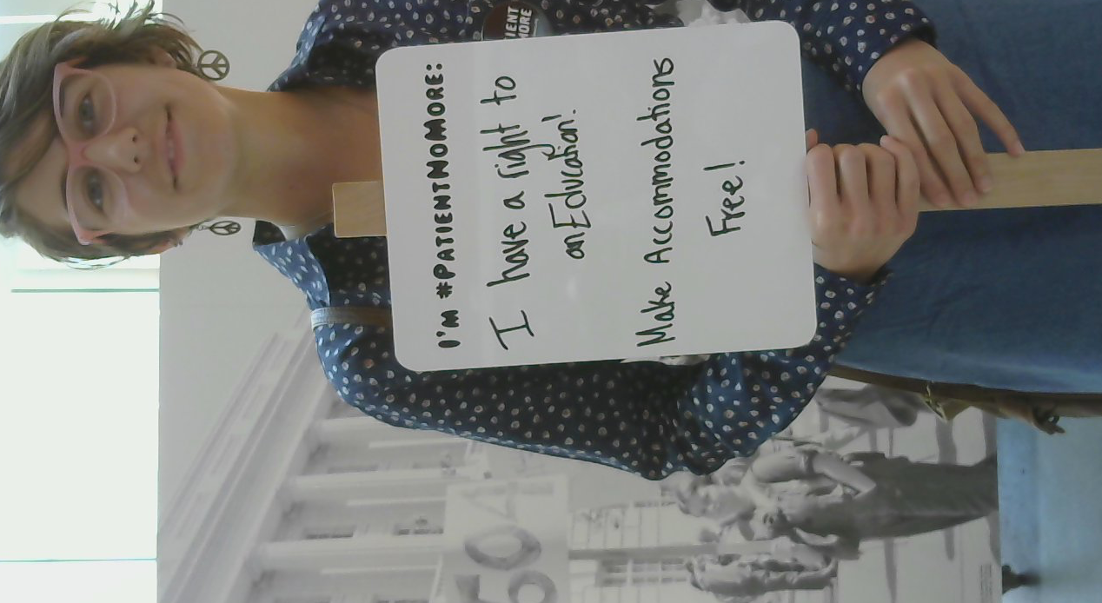
Activity: Ask your students to think about what infuriates them (it of course need not be disability-related), and use this as inspiration to complete the phrase: “I’m #PatientNoMore…” Have them create a sign with this written at the top, and to write what infuriates them below it. You can even have them take selfies with their signs!

Send your pictures to pklinst@sfsu.edu or tweet them using #patientnomore and @longmoreinst to join the conversation.
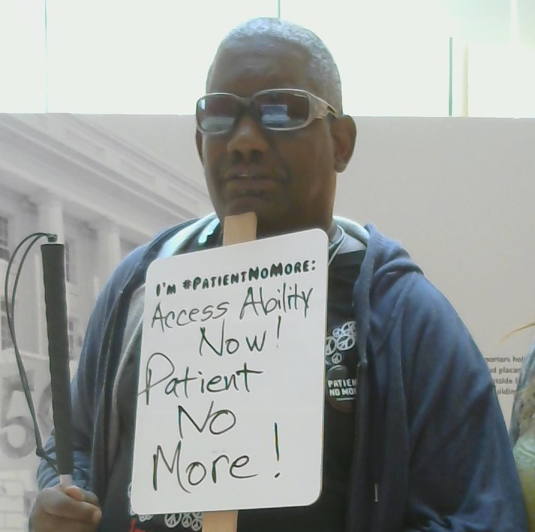

LESSON 8: AUDIO DESCRIPTION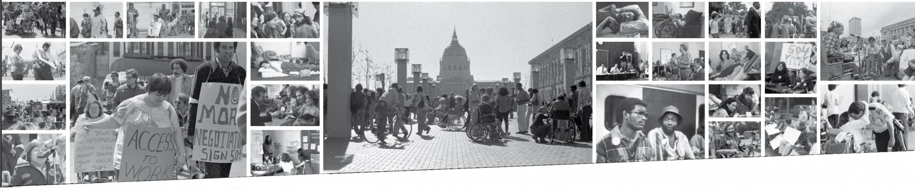

Lesson Description: Students will work together to create an audio description of an historic landmark. Students will then use poetry created from the photo mural at the Ed Roberts Campus to discuss how these poems support the visual information of the photomural.

To make the exhibit accessible to people with vision impairments or blindness, we provide an audio description track that reads all the exhibit text aloud, but also describes photographs with visual description that captions do not provide. For example, one exhibit photograph is described on the audio track:
A grinning Latina in a long white dress with embroidered flowers on the bodice, sleeve and hem, raises a fist. Flowers adorn her braids. Two clean-shaven white men in suits hold signs behind her. A light-skinned man with a black mustache and short dark hair next to her holds a sign: You don’t have to see it to know it.

Activity Part I: Ask your students to pair up. Person A describes an historic landmark by giving clues that describe visual elements and features to Person B and sees if Person B can guess the landmark. Afterwards, ask your students:
- What type of language was particularly useful for description? What was less useful?
- As the person trying to guess, did the description capture the feeling of being in that place? What more could have been offered?

Part II: When we decided to create the breathtaking photo mural in the Ed Roberts Campus Rotunda space, which can be accessed virutally at https://longmoreinstitute.sfsu.edu/sites/default/files/slides/PhotoMural%20small1_0.jpg, we were concerned that it would be very vision-centric, and that even providing description of the photographs might not adequately translate to the rich experience a sighted person would have taking in all the photographs together at once. As an access feature but also to enrich the exhibit for everyone, we commissioned two disabled poets to write pieces inspired by looking at the mural.

Have your students read the two pieces (pages 24-27) and discuss:

- What connections do you find between the content of the poems and the photomural?

- Where do the two poems intersect? How are they different?

- If you tried to articulate the feeling that you get when you look at the mural, is that similar to the feeling you get hearing/reading the poems?

Part III: After discussing the connection between the poems and the mural, and after your students have fully explored the 504 protests, discuss how these poems connect to the story of “Patient No More”:

- What is expressed in these poems that resonates with what you have seen in the Patient No More exhibit?

- Where do the two poems intersect? How are they different?

- Spoken word pieces have long been used with activist efforts. From reading these pieces, do you find spoken word to be a powerful way to express activist sentiments? What might be gained from using spoken word in conjunction with activist efforts? What other mediums can be or have been used?

[Link to audio/ASL]

We Need a Great Flock of Stories
Poem by Eli Clare

Each photo: one
story, two; two stories,
three; three stories,
four, multiplied.
I read the placards,
pins, slogans: No more
negotiating. Enough.
Sign 504 now. IAM.
Human rights.
Solidarity.
Let
their
words
rumble.
What lies between
these photos, behind
and beneath—whose voices,
languages, poems?
I read the signs
they carried: Access
to work. Can’t
back down. You might
break your neck. Sign
504. Remove the barriers or
we’ll level them.
Let
their
words
sink in.
They planned rebellion, slept
rebellion, talked rebellion, argued
rebellion, strategized rebellion,
laughed and cried and
refused to back down. They
wrote: The hunger strike
is in its 15th day! Keep
your campaign promises.
MCW supports 504.
Suffered enough. Please
no more. Bastante.
Let us
slur,
stutter,
drool
our rebellion.
Trail our fingers across
this history, feel its cracks,
bumps, holes, how much has been
lost and whitewashed.
Not one but two, not
two but three—we need
a great flock of stories.
They left us:
Sign 504. Handicapped
human rights. Disabled
In Action. Human
rights for all. 504
victory.
Let
these photos
be signposts, neither
the beginning nor the end.
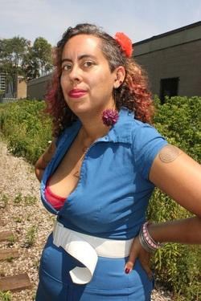
cripstory
by leah lakshmi piepzna-samarasinha
[link to audio/ASL]
time doesn't move. we move through time.
- gabriel teodros
you're six and your mom has polio but she won't talk about it and you know you are a freak but you don't read in history class about crips who locked down a building that says it wants to help us and we say it's saying fuck you to us. no one tells you about a mexican femme who paints her back brace or her fake leg and makes our with chavela vargas while she paints her disabled queer brown visions. you don't read about the freak show, the ugly laws, the million indigenous words for disability that have nothing bad in them. you just know your brain is weird and you can't ride a bike and you fall down in the shower and get sick all the time and see visions. you're lucky to have bad HMO health insurence. cripstory.
no one tells you that sick and disabled folks like lions make history. your mom is busy passing as fuck. when you are 21 she'll say you know I had polio. right? you know I can't walk down the street more than 30 feet without pain right? you don't/know she is surviving the best she can by faking it, something she'll teach you. you are both making history. two disabled women, one white and straight and workingclass, one brown and queer and working class, surviving. cripstory.
it's not safe for you to be soft. to ask for things. you run away, an achey hipped girl on the bus. you're making history. ten years later you see a queer/ disabed/porn where a white queer femme in a wheelchair has sex in the disabled stall. waits for the accessible bus the way you pray for a seat in the crip zone. you stammerstutter. can you claim the d word. you're making history.
when you're in high school ADAPT locks down their wheelchairs and scoooters in front of busses and trains who are violently apologetic no room for us. history. in 2002 disabled queer people of color who will be your friends call out the white disabled queer conference on racism. cripstory. in 1993 your friend gets a double amputation after they get run over the first time they train hop. in 1994 their tiny zine, ring of fire, about queer and crip and genderqueer , doing drag while amputee, falls into your 19 year old hands. twenty five years ater you meet at a sins invalid show. you go to brunch, talk about your crip sex moments, collaborate in art and love. they go to speak to the nursing students about being disabled. teach crips at their physical rehab job how to fuck, love, be in their bodies. cripstory
and when I was two years old, you all said fuck it and took over. you crawled.
you made everyone stare cause everyone already started anyway. you crawled up that fight of stairs because that's what rehab wanted you to do. crawl. because what else could you do but crawl. because we know crawling as art. as just another way our disabled bodies know how to move. as normal. took over that building that never helped us. made out with each other. made love. made history.
crip carnaval. the opposite of the nursing home. you got free. cripstory.
we don't know what we give birth to. we don't know what just keeping breathing as disabled folks will help us give birth to. we're not supposed to give birth. our genes are dangerous.
we are dangerous when we find each other. at the bottom of the stairs. in the crip seats. in the waiting room at kaiser or acupuncture. on tumblr. we are dangerous. all these points of cripstory like stars in the sky. you didn't know what you would give birth to. occupying the department of rehab. making out
reaching to us almost forty years later. all our sweet drooling brokenbeautifulugly danger. a cosmos of crip story, all these moments are stars in the disabled genius sky.

APPENDIX A: ADDITIONAL RESOURCES

Additional Resources and Reading Materials tied to 504 history:

Fading Scars: My Queer Disability History by Corbett O’Toole
This new book features a chapter on O’Toole’s experiences as a 504 protester.
Becoming Real in 24 Days by HolLynn D’Lil
With some 200 photographs, this memoir takes you inside the 504 protests. A chapter is available for download on her website, which would make a useful reading to accompany the “Patient No More” curriculum or you can purchase the book and find additional readings.
“The Twentieth Anniversary Victorious 504 Sit-In for Disability Rights”, by Disability Rights Education and Defense Fund
This pdf downloadable booklet provides a range of readings, first-hand accounts, and photographs about the 504 protests.
The Power of 504 Video (18 minutes)
“A Layperson’s Guide to Section 504” by Peter Coppelman
A short reading that could be passed out to students to accompany the exhibit.
“Voices of 504 Reprinted from The Independent, Summer 1977”
A short reading that could be passed out to students to accompany the exhibit.
“Section 504 History” by Kitty Cone
A short reading that could be passed out to students to accompany the exhibit.
“A Moving Wave” by Tarri L. Tanaka
A short reading that could be passed out to students to accompany the exhibit.
“Remembrance of Things Past” by Michael Williams
A short reading that could be passed out to students to accompany the exhibit.
“Confronting the D.C. Power” by Michael Williams
A short reading that could be passed out to students to accompany the exhibit.
The Activist’s Handbook by Randy Shaw
Chapter 8 “Getting Started” includes a history of the 504 protest.
“Lomax’s Matrix: Disability, Solidarity, and the Black Power of 504,” by Susan Schweik in Disability Studies Quarterly 31.1 (2011).
An advanced reading that dives into the hierarchies within the movement and the intersectionality of race and disability in the 504 protests.

Additional Resources and Readings about Disability History (General):

Bancroft Library Disability Rights and Independent Living Movement Online Oral Histories
A large collection of oral histories from people who participated in the disability rights
movement in the Bay Area.
Smithsonian Museum “EveryBody” virtual exhibit
An artifact history of disability in America
The Disability Rights Movement: From Charity to Confrontation by Doris Zames Fleischer and Freida Zames (Temple U.P., 2001).
A useful text for disability rights movement history.
A Disability History of the United States by Kim Nielsen (Beacon press, 2012).
A useful text for U.S. disability history including but also beyond the disability rights movement.

Adapted from materials by Eva M Oliver and Shelley Goulder, 8th grade Humanities teachers at Life Academy of Health and Bioscience.
Adapted from materials by Eva M Oliver and Shelley Goulder, 8th grade Humanities teachers at Life Academy of Health and Bioscience.
Adapted from materials by Eva M Oliver and Shelley Goulder, 8th grade Humanities teachers at Life Academy of Health and Bioscience.

